TRƯỜNG THCS PHAN CÔNG HỚN
TỔ TIẾNG ANH
TIẾNG ANH 6
TUẦN 23 (TỪ 17/02/2025 ĐẾN 22/02/2025)
PHIẾU TỰ HỌC
PERIOD 67+68+69: UNIT 7: MOVIES
LESSON 2
Sách giáo khoa trang 57:
New words
terrible – fantastic
sad – funny
awful – great
boring – exciting

Reading
- Underline the correct sentence:
Picture Day Don’t watch this movie!
Sally’s Travels What a fantastic movie!
- Answer the questions:
1. a sad drama
2. It was boring.
3. an action movie
4. It was exciting.
5. She was very funny.

Sách giáo khoa trang 58:
Grammar
- Circle the correct verbs:
1. was 4. were
2. was 5. Were
3. was 6. was
- Complete the dialogue:
1. It was The Great Bananas.
2. Yes, it was very funny.
3. It was on at 4:45 p.m.
4. They were Time 7 and Earthlife.
5. They were exciting.
6. They were on at 7:30 p.m. and 9 p.m.
_________________________________________________________
SỬA BÀI TẬP TUẦN 22
- Choose the best option (A, B, C or D) to complete each of the following sentences.
1. The movie was so __________ that I smiled at the end.
A. awful B. funny C. fantastic D. terrible
2. Alex can’t watch __________ movies. He thinks they’re too scary and he always has bad dreams after watching them.
A. comedy B. action C. horror D. drama
3. Rowan Atkinson is a famous _________. His famous character is Mr. Bean.
A. act B. acting C. actor D. actress
4. I __________ to make a sandwich this morning but it __________ horrible.
A. try/ was B. try/ is C. tried/ is D. tried/ was
5. My brother enjoys watching _________ movies although he feels scared of haunted houses and mysteries.
A. science fiction B. horror C. animated D. comedy
6. Tom and Jerry is a/an _________ movie. The characters are drawings, not real people.
A. science fiction B. drama C. action D. animated
7. Susie loves acting so she wants to be a _________ when she grows up.
A. dancer B. farmer C. teacher D. actress
8. A lot of exciting things happen in this kind of movie.
A. drama B. action C. animated D. science fiction
9. We like __________ movies. They’re about space and the future.
A. horror B. drama C. science fiction D. comedy
10. Do you want to see a film on Saturday?
A. Yes, I will. B. Sounds great. C. No, I didn’t. D. I didn’t see it.
III. Write a suitable word for each picture.
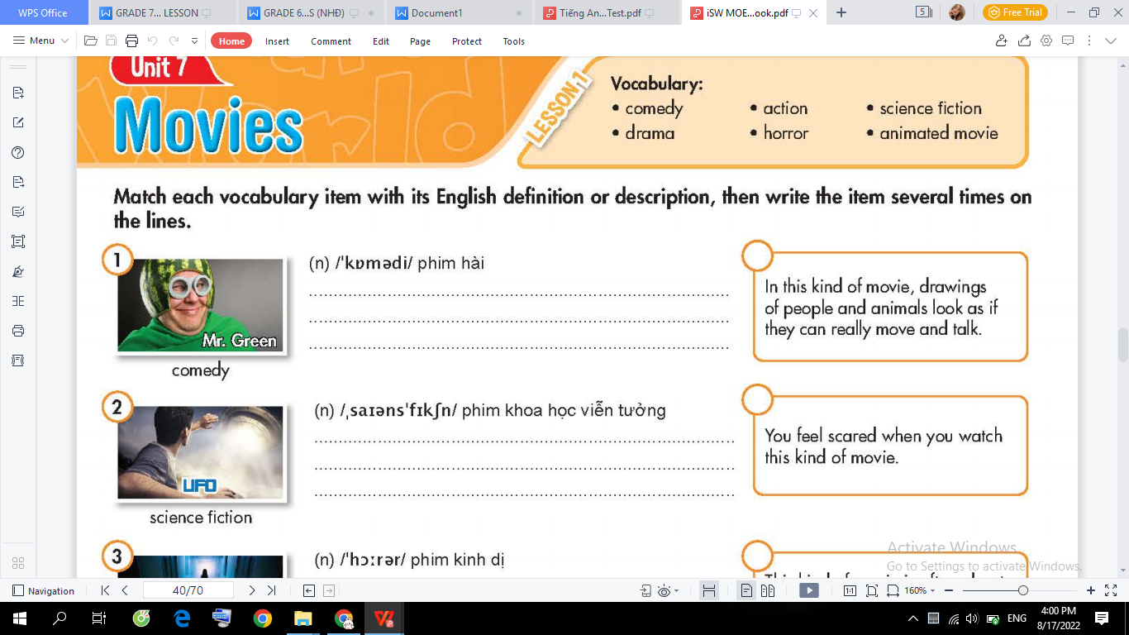 | 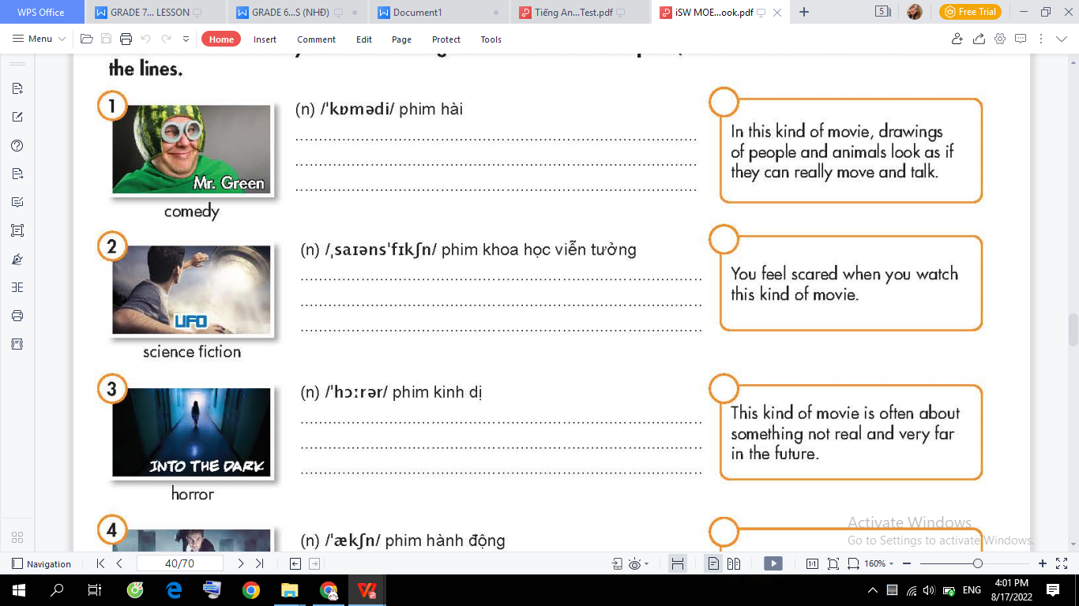 | 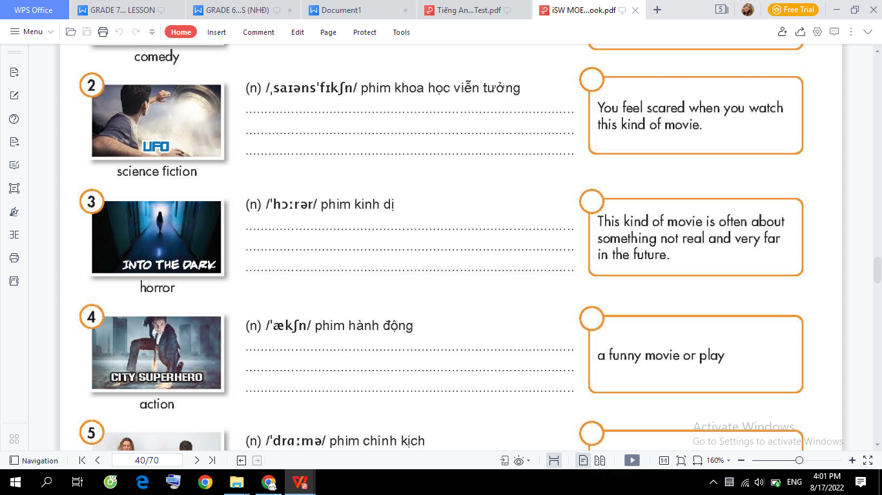
comedy | Science fiction | horror
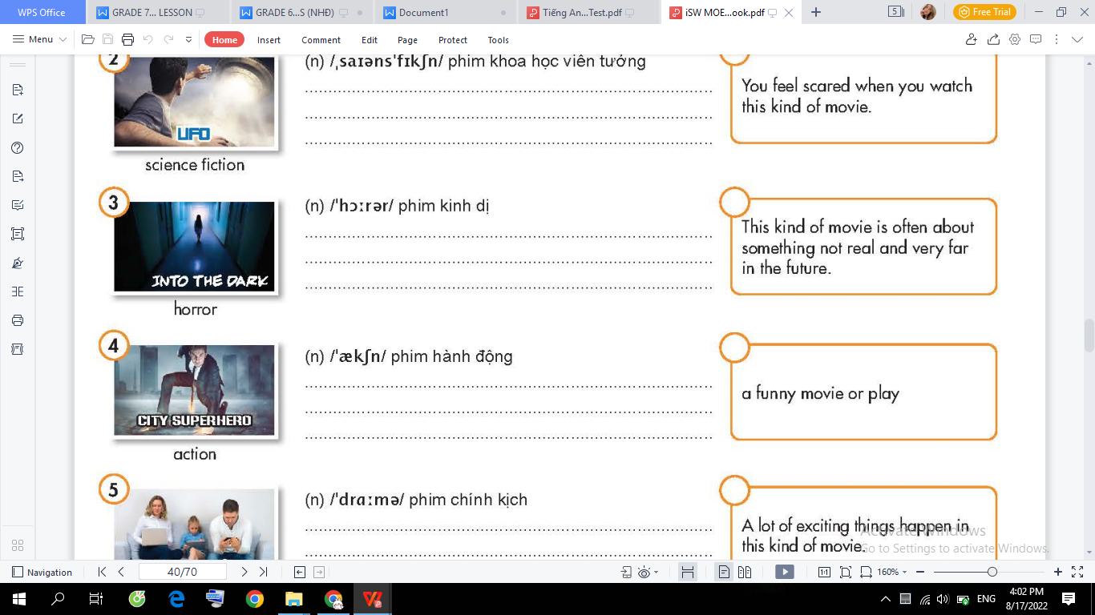 | 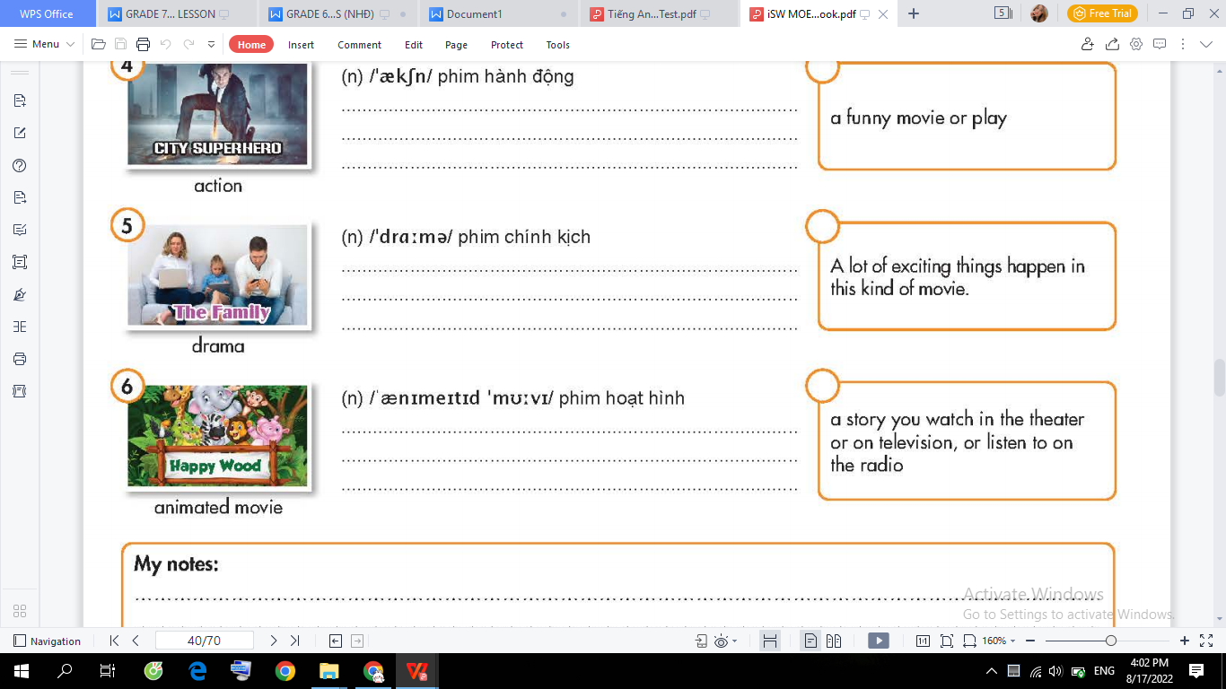 | 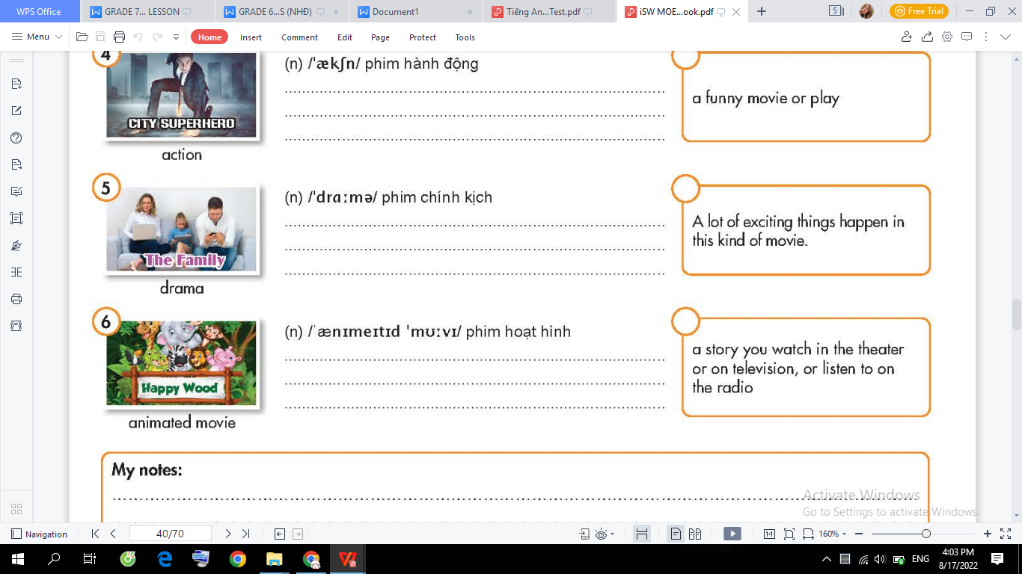
action | drama | animation

- Write a suitable preposition in the blank.
- Mary’s birthday is in January.
2. We often go out on Saturday evenings and come back home at 11 at night.
3. My English class always starts at 8 o’clock.
4. In Canada, it always snows in the winter.
5. What time do you usually get up? - I usually get up at 6 a.m.
- Let’s go to the swimming pool on Sunday morning.
- We’ll take a vacation to Italy in December.
- I never drink coffee at night. However, I always drink milk in the morning.
- She always visits her parents on Christmas Day.
- in 2050, people might live on Mars.

- Put the times in their correct category.
the morning Sunday noon spring
my birthday 10:30 May 5th the weekend
- Monday evening night November
half past seven winter Tuesday afternoon the 19th century

at | on | in
half past seven  10:30  Noon  Night  the weekend | my birthday  Sunday  Monday evening  May 5th  Tuesday afternoon  the weekend | the morning  2002  Winter  spring  November  the 19th century

UNIT 7: MOVIES
Lesson 1-3 (Pronunciation)

- Find the word whose underlined part differs from the other three in pronunciation.
1. A. performance B. comedy C. terrible D. September
2. A. magic B. acting C. fantasy D. island
3. A. novel B. soccer C. role D. comic
4. A. parks B. schools C. theaters D. museums
5. A. boxes B. dishes C. gloves D. Kisses

- Choose the word that has a different stressed syllable from the rest.
- A. doctor B. student C. engineer D. designer
2. A. comedy B. drama C. fiction D. cartoon
3. A. documentary B. channel C. cartoon D. comedy
4. A. money B. ticket C. audience D. performance
5. A. beautiful B. interesting C. awesome D. Amazing

- Write the correct form of the words in the brackets.
1. It is a very funny movie with lots of laughter and the ending is hilarious. (FUN)
2. I love watching animated movies. My favorite one is Doraemon. (ANIMATION)
3. I like the film at all. It was so interesting (INTEREST)
4. The movie was so sad that I cried a lot. (SADLY)
5. Horror movies are very scary so I don’t usually watch them. (SCARE)

- Put the words in the correct order to make correct sentences.
1. are/ going/ We/ the/ to/ cinema/ this weekend/ .//
We are going to the cinema this weekend
- funny/ Mr. Bean/ is/ animated/ a/ movie/ .//
Mr.Bean is a funny animated movie
- There’s/ new/ a/ drama/ TV/ tonight/ on/ .//
There’s a new drama on TV tonight
- movie theater/ seven o’clock/ Let’s/ at/ meet/ in front of/ the/ .//
Let’s meet in front of the movie theater at seven o’clock
5. goes/ family/ My/ in/ camping/ usually/ the/ summer/ .//
My family usually goes camping in the summer

